**Project**

Let’s take an Voting application for this project and first lets understand how the application works.

An application developed by Docker to demonstrate various features available in running an application stack on docker. First familiarize with application first. This is a sample voting application for the user to vote and to show the results on another interface. Let’s see how it **works in Docker.**

Application consists of various components such as

1. Voting app: Developed using python for user to vote which basically is choose between two options like Cat and Dog.
2. Redis – In-memory DB: When you make a selection, the vote is tored in Redis.
3. Worker –Vote is process by this worker application written in “.Net”.
4. Postgre SQL: Serves as DB. Worker application sends the vote to this DB and it updates the value for cats or dogs in the table.
5. Result app: Finally, the vote will be displayed in another interface which is developed in NodeJS. This application reads the count of votes from postgre DB and displays it to the user.

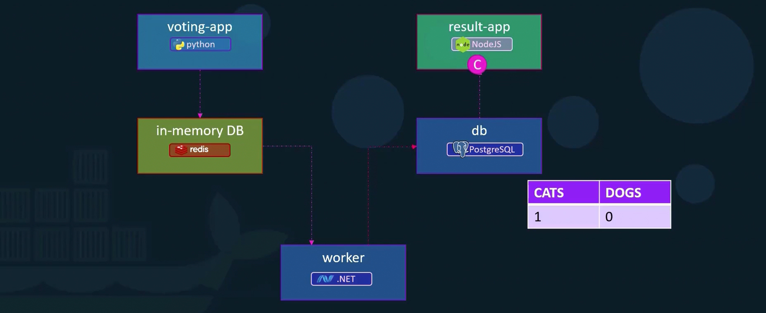

Let’s us assume all the Images are build and are available on docker repository. First, we will start with Data layer. Let’s try to run redis conatiner first and then postgre SQL. Include ‘-d’ in the command to run the conatiner in the background. And also add naming to all the conatiners that we are deploying now. Next we will start with application services, we will deploy frontend app for voting interface by running an instance of voting app image. Name this instance as Vote. Since, this 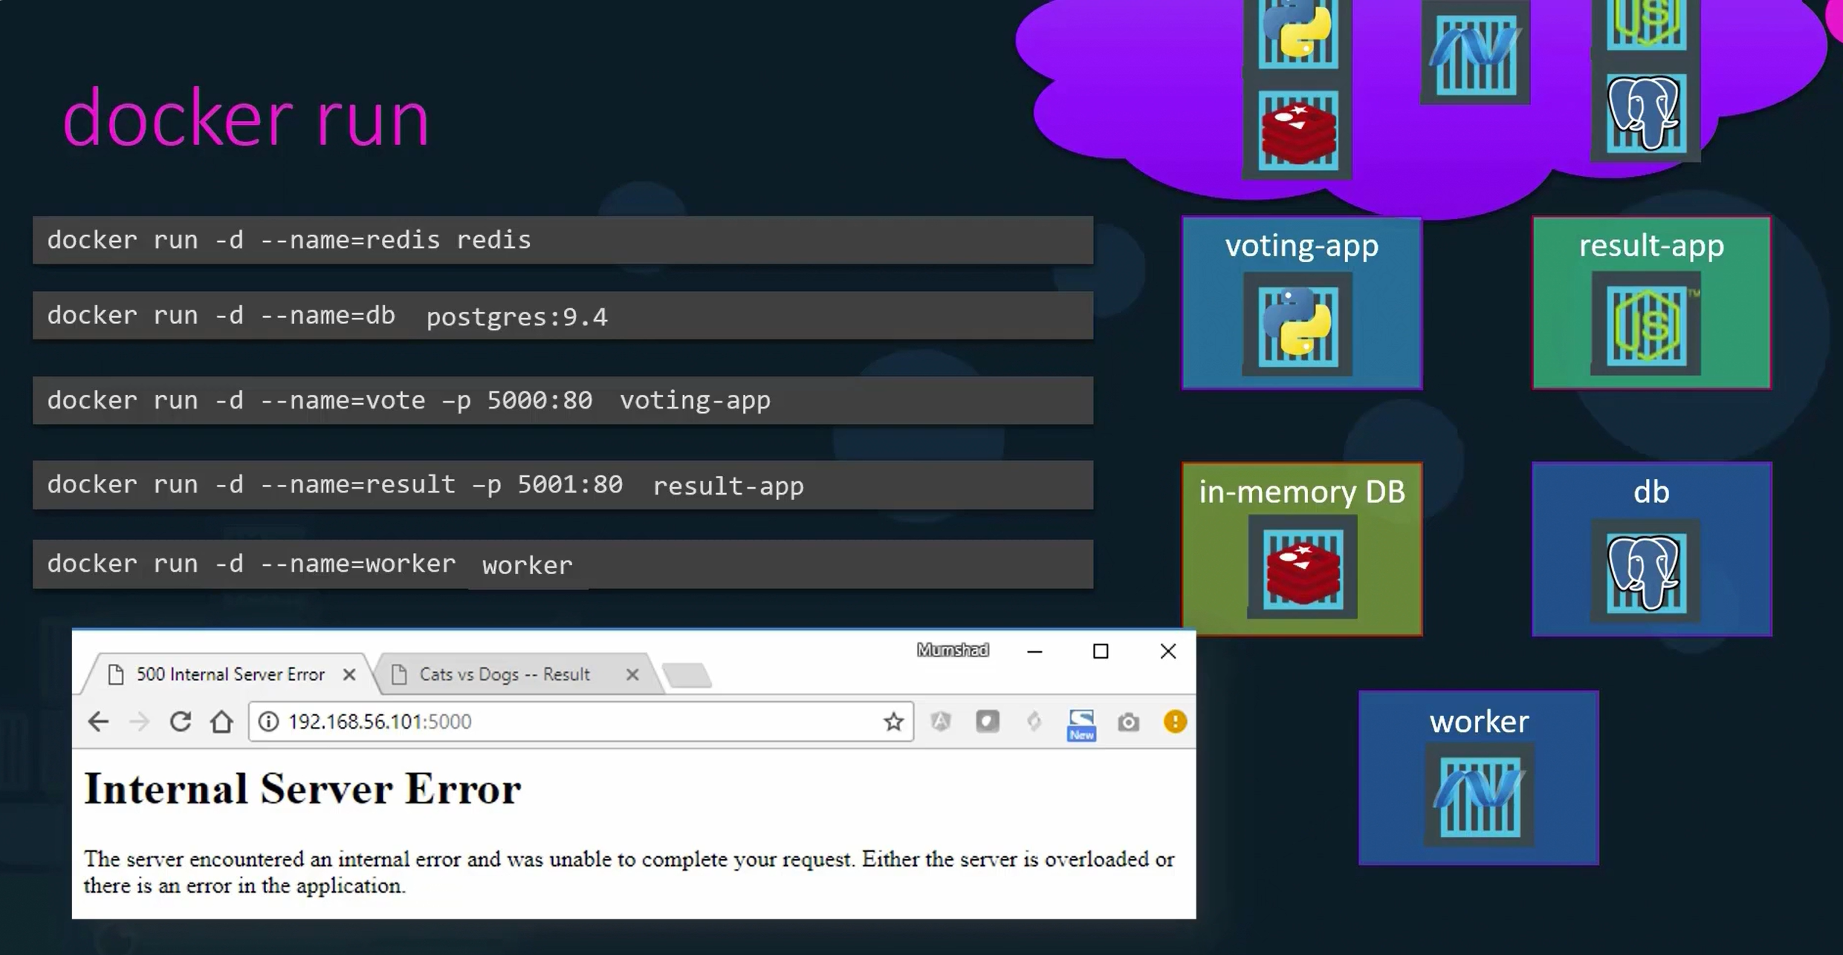is a web server, it will have a web UI running on port 80 and we publish that to port 5000 on the host system. So, that we can access it form our browser. For Showing the results we will deploy the result-app image and made it accessible with port 5001. Finally we will deploy the worker by running an instance of worker image. We can see all the instances are running on the host.

But we were not able to access the voting application. There is some error. We havn’t linked the applications yet. We have to use links in order to establish communication between two services.

For example, voting app web server is dependent on redis service. As the voting web server starts it will look for redis service from this piece of code. 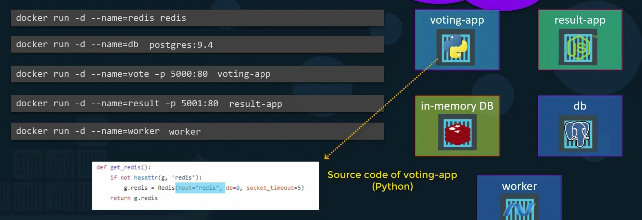To make the voting app aware of redis service we need to a link option while running the voting app container to link it to the redis conatiner. ”**redis: redis”** 🡪 name of redis conatiner: name of host that voting app is looking for. In this case both are redis. We named the redis conatiner as redis and in the source code of voting app we specified host name as redis to look for. 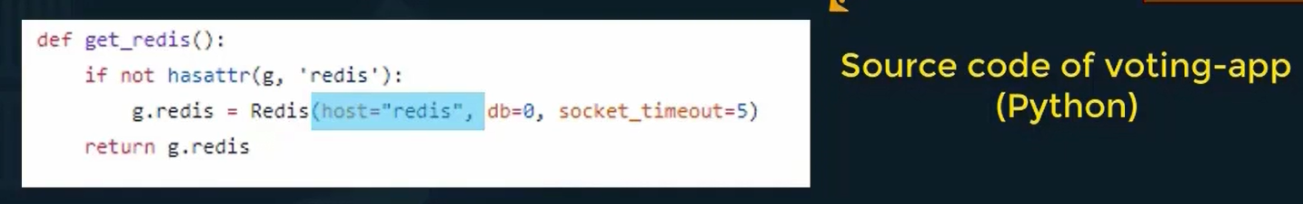This is why we have to name the conatiner, it will be useful while creating a link.

With link option in docker run command, what exactly it is doing?

**Note:** It creates an entry into the etc hosts file on the voting app container, adding an entry with the host name Redis, with the internal IP of the redis container.

Similarly, we will add a link for result app to communicate with database. 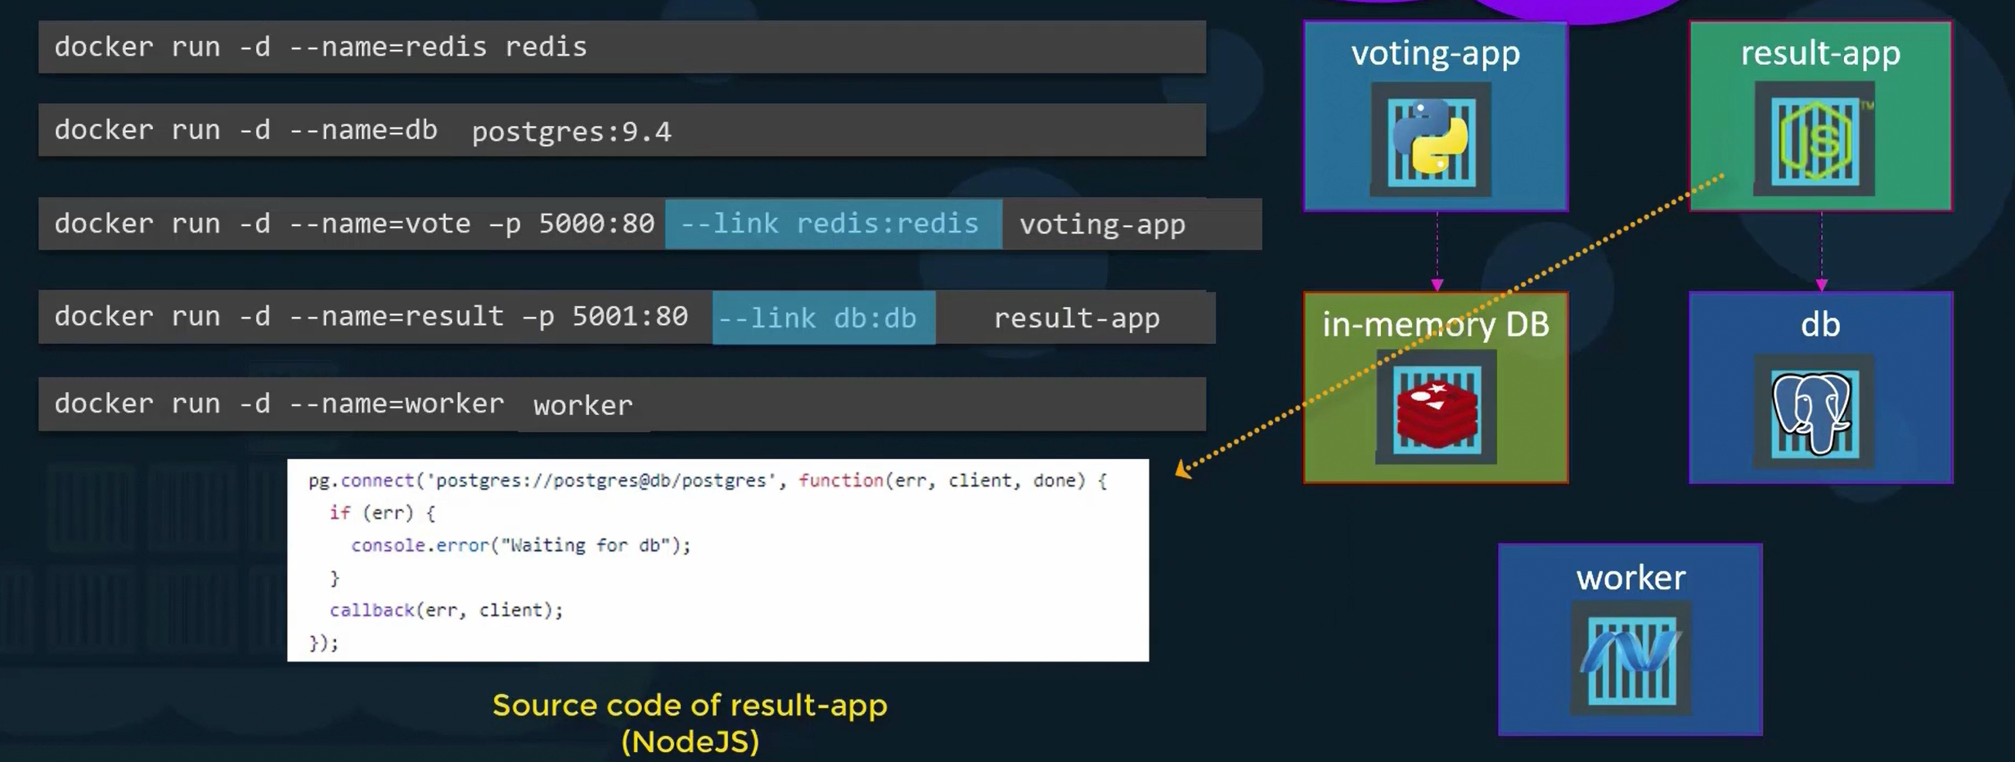

Finally, the worker application, requires connection to both redis and postgre SQL DB. 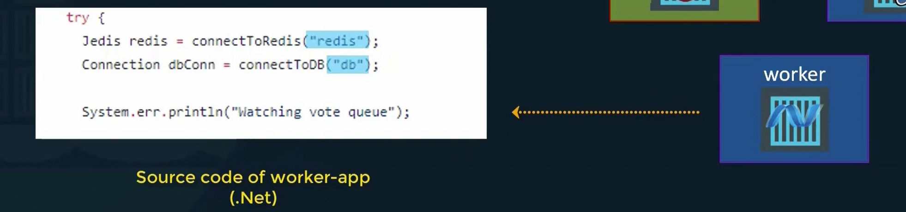So, we need to add two links while running worker conatiner. **Final Docker commands to run conatiners:** 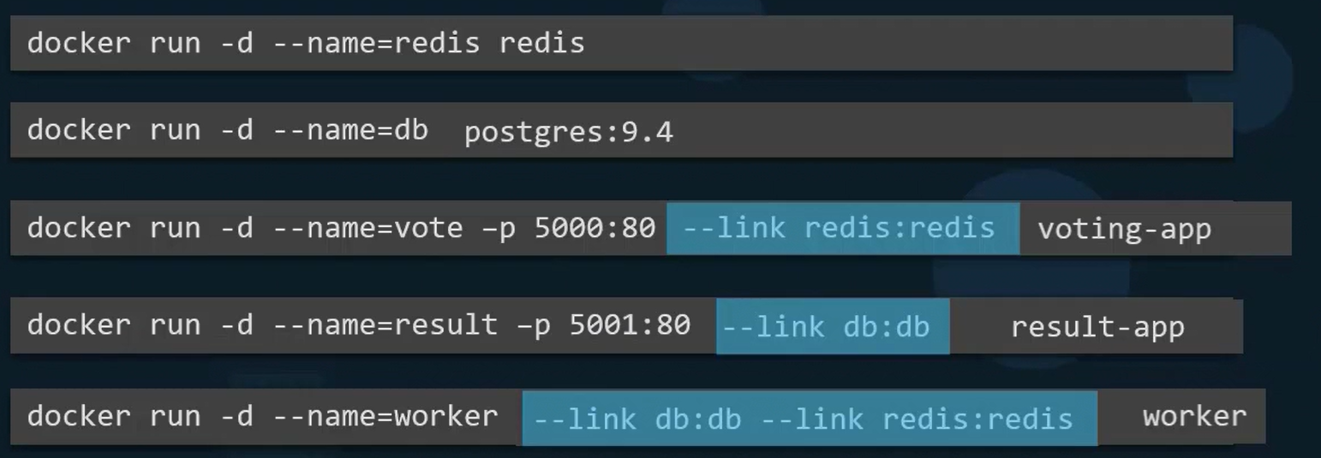We seen how Voting app works in Docker containers. Now lets see how to deploy the same in K8s.

**Deploying Voting app on K8’s**

Its important to have a clear idea what we are trying to achieve and plan accordingly before we get started. We already know how application works. It’s good idea to write down what we plan to do.

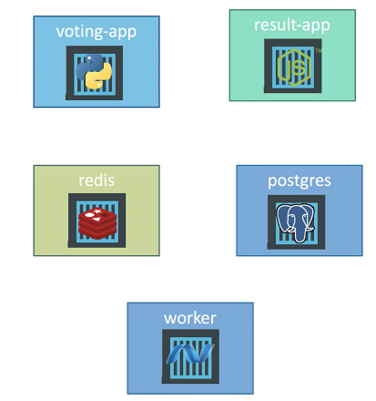**Goals:**

1. Deploy these applications as conatiner on K8 Clusters.
2. Then enable connectivity between the containers, so that the applications can access each other and the databases.
3. Then enable external access for the external facing applications which are the voting and result app. So, that the users can access the web browser.

**How do we do this?**

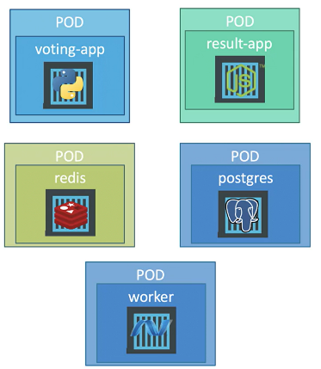**Note:** We cannot deploy conatiners directly on kubernetes. The smallest object that we can create in K8s is Pod.

**Steps:**

1. **Deploy as Pods:** So, we must deploy these applications as a pod on K8 cluster. Or we can also deploy them as replica sets or deployments. First, for the sake of simplicity we will stick to pods. Later we will see how to convert that to a deployment.
2. **Create Services (ClusterIP) – for redis and db:** Once the pods are deployed. Next step, we need to enable the connectivity between the services. So, its important to know what are the connectivity requirements are? We must be very what application requires access to what services.

We know that the redis database is accessed by voting app and worker app. Voting app says the vote to the redis db and the worker app reads the vote from redis db. Also, Postgre SQL db is accessible by worker app to update the total count of votes and also accessible by the result app to read the count of votes to display in the result web page.

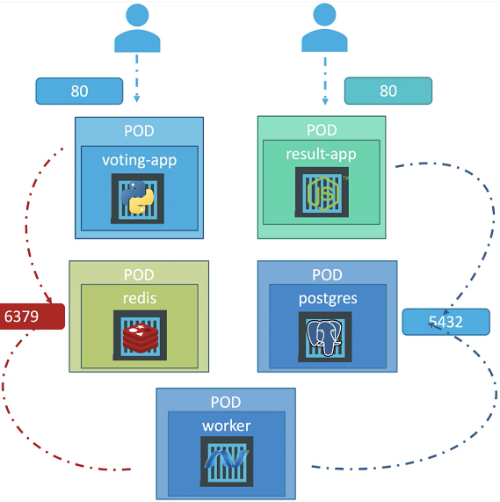When voting app is used by external user and the result app is also access by external user to view the results. Most of the components are being accessed by another components except for the worker app. You can see arrows going into all of the components and there are no arrows going into worker. Which means none of the other components nor external users are accesing the worker app. The worker app simply reads the count of votes from redis db and updates the count of votes in Postgre SQL DB.

Now, while the voting app had a python web server that listens on port 80 and result app Node JS based server that listens on Port 80. And the redis db service that listens on port 6379 and the postgre SQL service listens on port 5432. The worker app has no service. Because it’s just a worker and not accessed by any other service nor the external users. So, just keep that in mind.

**How do you make one component accessible by another?**

Say, for example how do you make redis db accessible by voting app. To do that we cannot use the IP of the pods as they will change after restart/destory/replaced. We may also run into issue when we try to scale up our application in future. The right way to do it is to use a service.

**Note:** We know that service is used to expose an application to other application or to the users for external access.

So, we will create a service for the redis pod. So, that it can be accessed by the voting app and worker app. We wil call it ‘redis’ service and it will be accessible any where in the cluster by the name of the service – ‘redis’.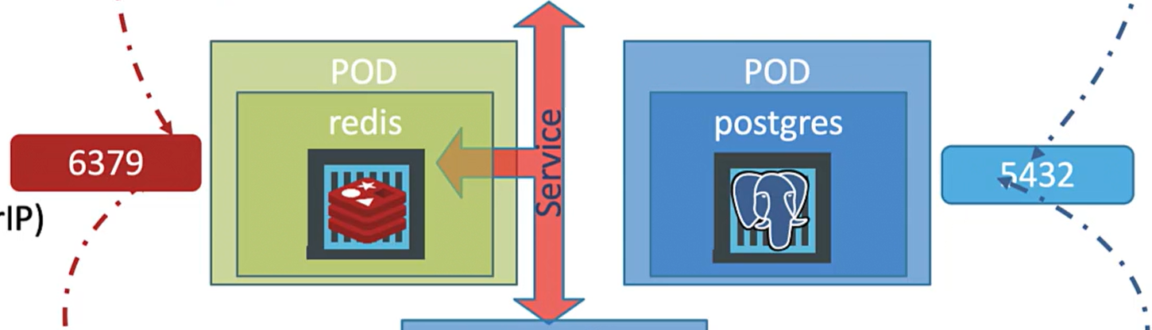**Why this name is important?**

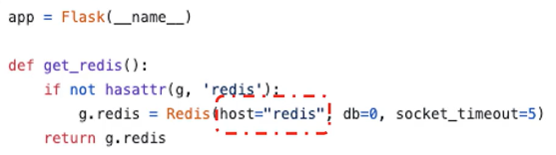The source code with in the voting app and worker app are hard coded to point to a redis database running on the host by the name ‘redis’.

Voting app:

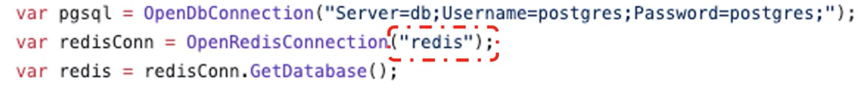Worker app:

So, its important to name your service as redis. So, that these applications can connect to the redis db. This is not a good practice to hard code stuff like this within the source code of an application. But for simplicity we follow this application as it is developed.

Now, these services are not to be accessed outside the cluster. So, they should just be of type ClusterIP.

We will follow the same approach of creating a service for the postgre SQL pod. So that Postgre SQL DB can be accessed by worker and result app. 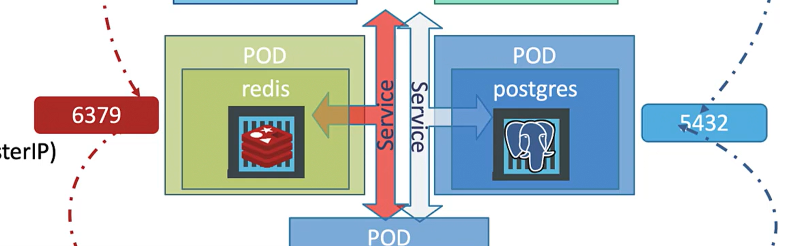What should we name the postgre SQL service. For that we have to loook into the source code of result app and worker app. Below are images form source code of the result app(image 1) and worker app (image 2).

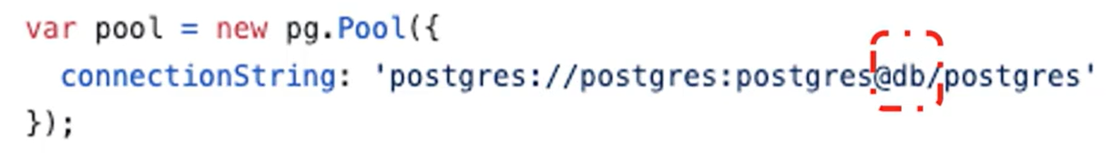 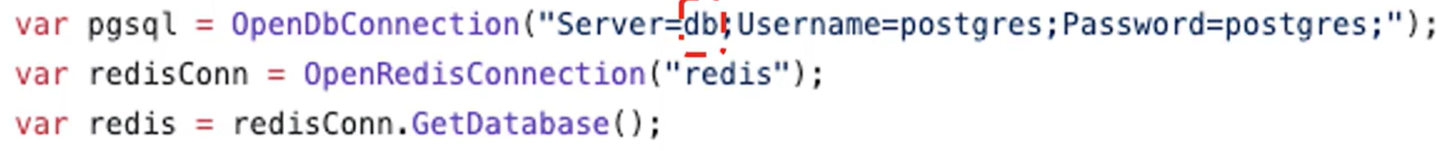

They are looking for a database at the address ‘db’. So, the service that we create for postgre SQL also should be named as ‘db’. Also, note that while connecting to the db the worker and result app passing username and password to connect to the database. Both username and password are set to postgress. When we deploy the postgre SQL db pod we must make sure that we set these credentials for it as intial set of credentials while creating the database.

So far we created services for redis and db.

1. **Create Services (NodePort) – for result and voting app:** Next task is to enable external access. So, for this we can use a service type called NodePort. We create services for voting app and result app and set their type to NodePort. We can decide on what port we are going to make them available on. It can be a high port with port number greater than 30000.

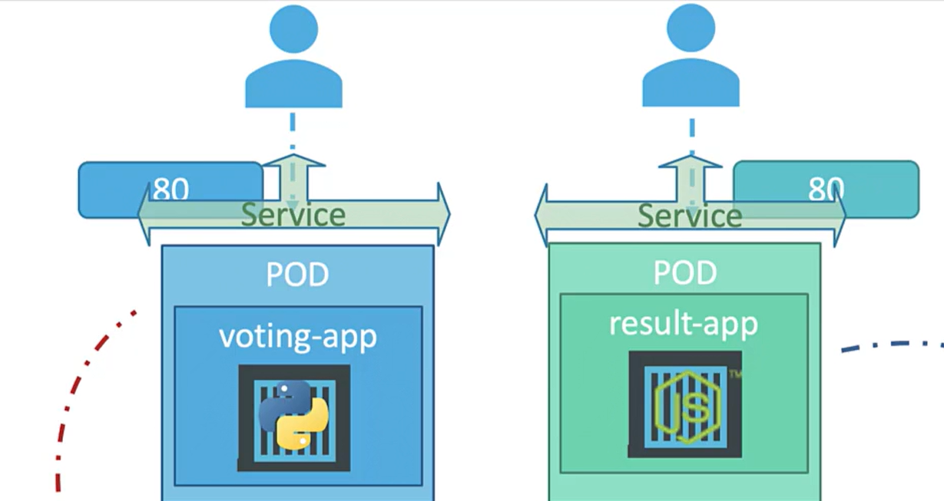

**Summarize:**

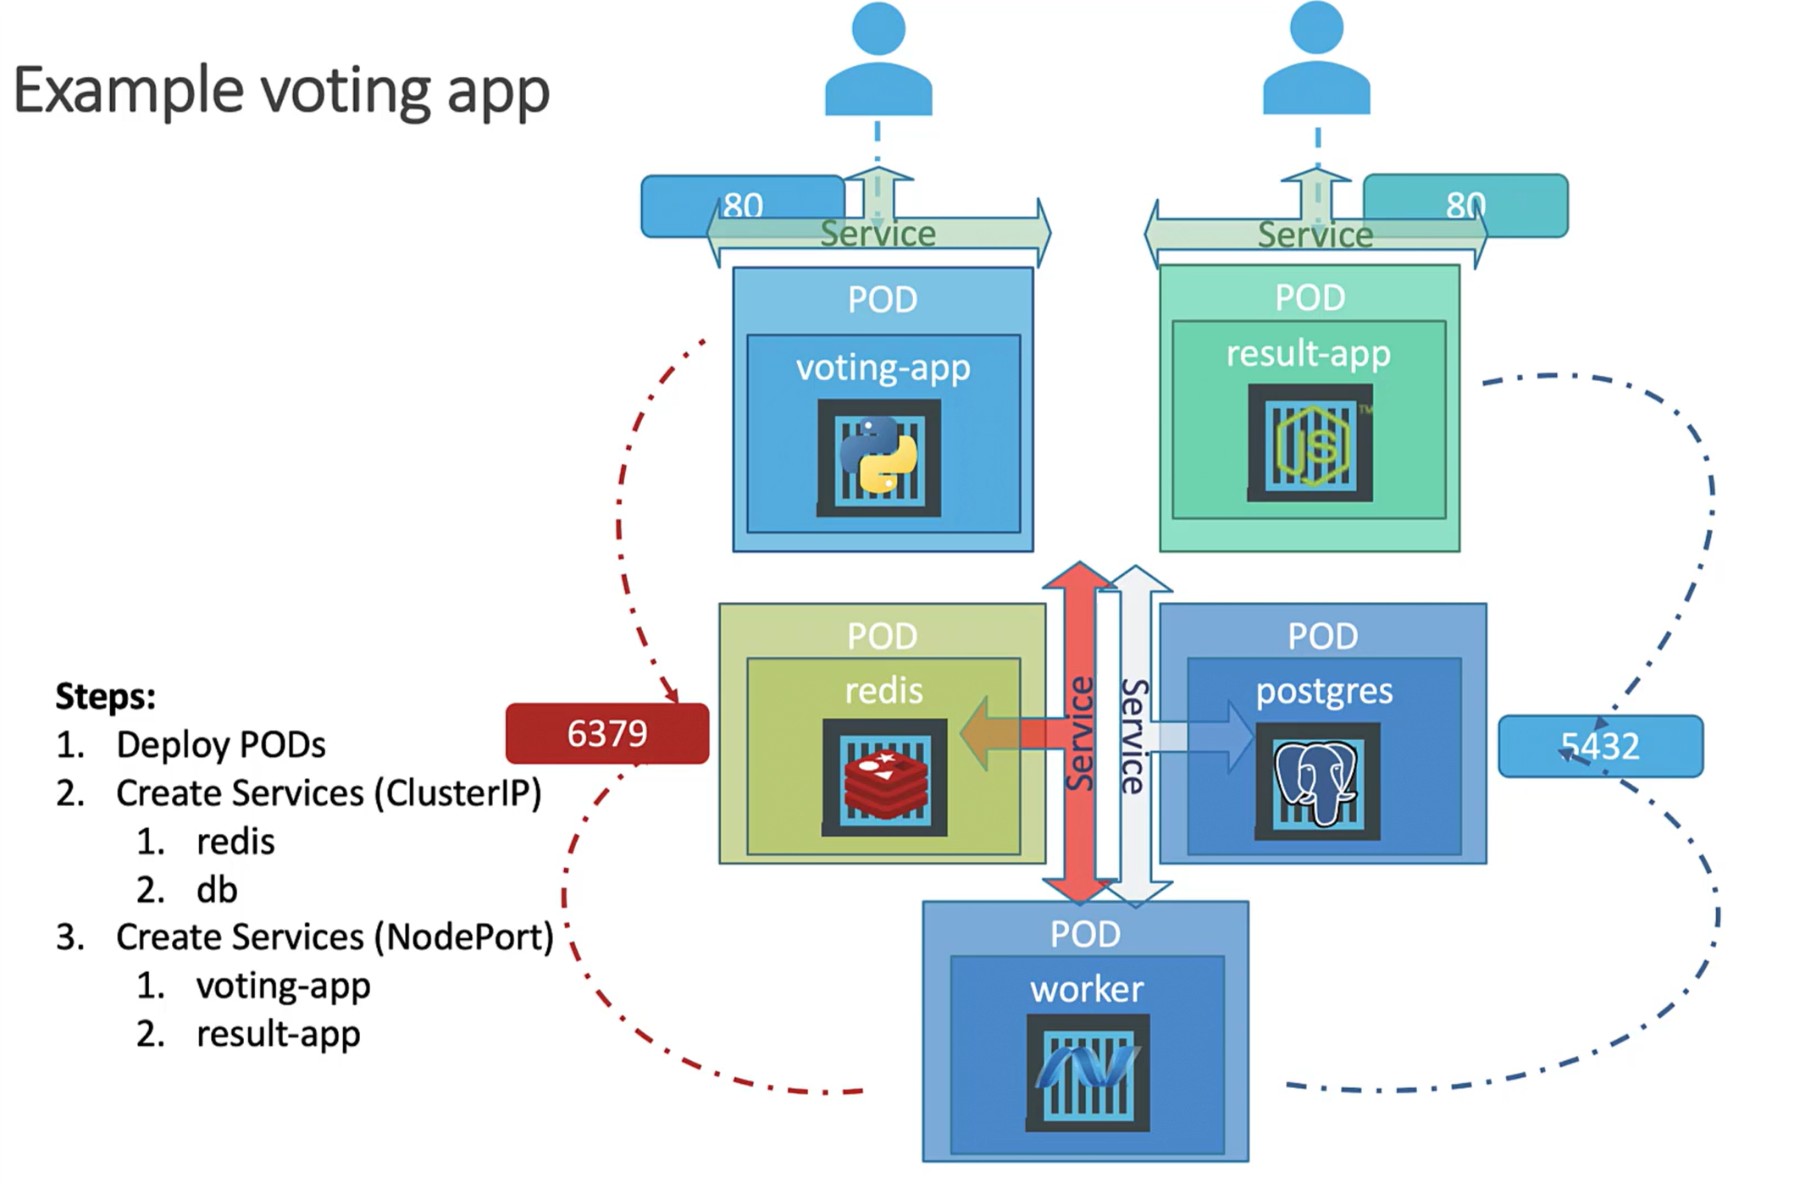We will be deploying 5 pods in total. And we will have four services – one for redis and one for postgre SQL. Both are **internal services**, So they are of **ClusterIP.** And we then have two externla facing services for voting and result app. However we have no service for worker pod and this is because it is not running any service that must be accessed by another application or external users. It is just a worker process that reads from database and updates another.

**Note:** A service is only required if the application had some kind of process or database service or web service that needs to be exposed and accessed by others.

**Image names from docker hub:** 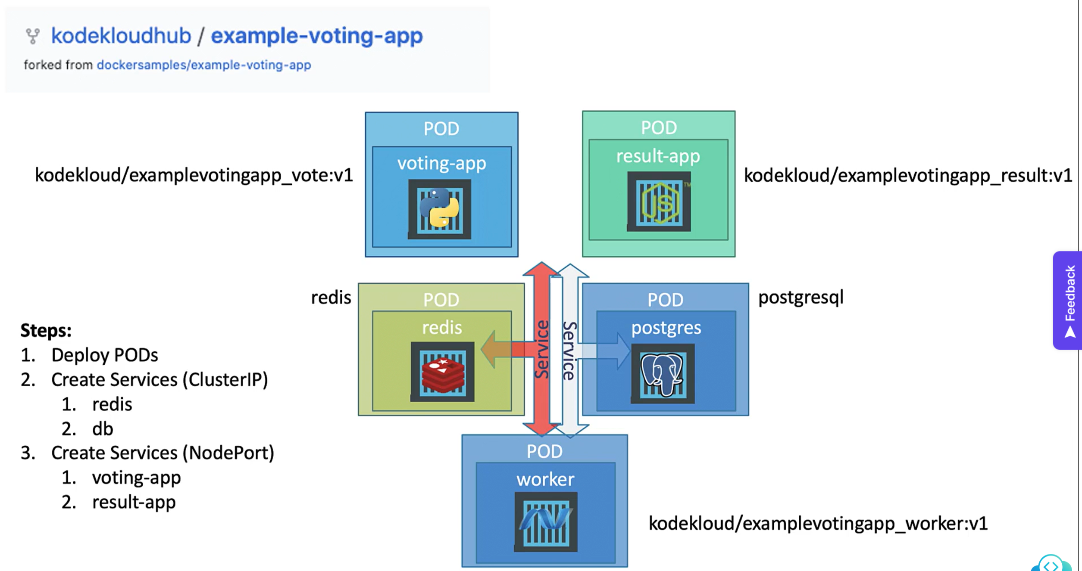

**Deploying Voting app on Minikube cluster**

Create Voting-app folder. Then we have to create pod-definition files for each of component within the application. Below are pod definition files. We will have same app name in labels of all pod files.

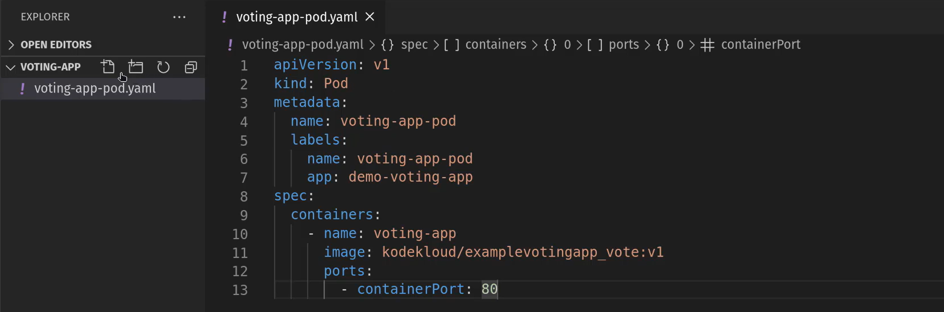 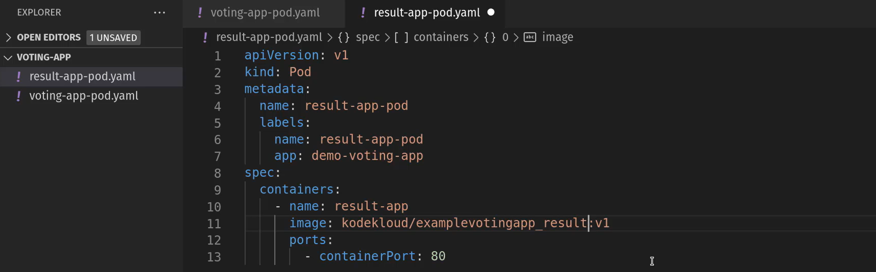 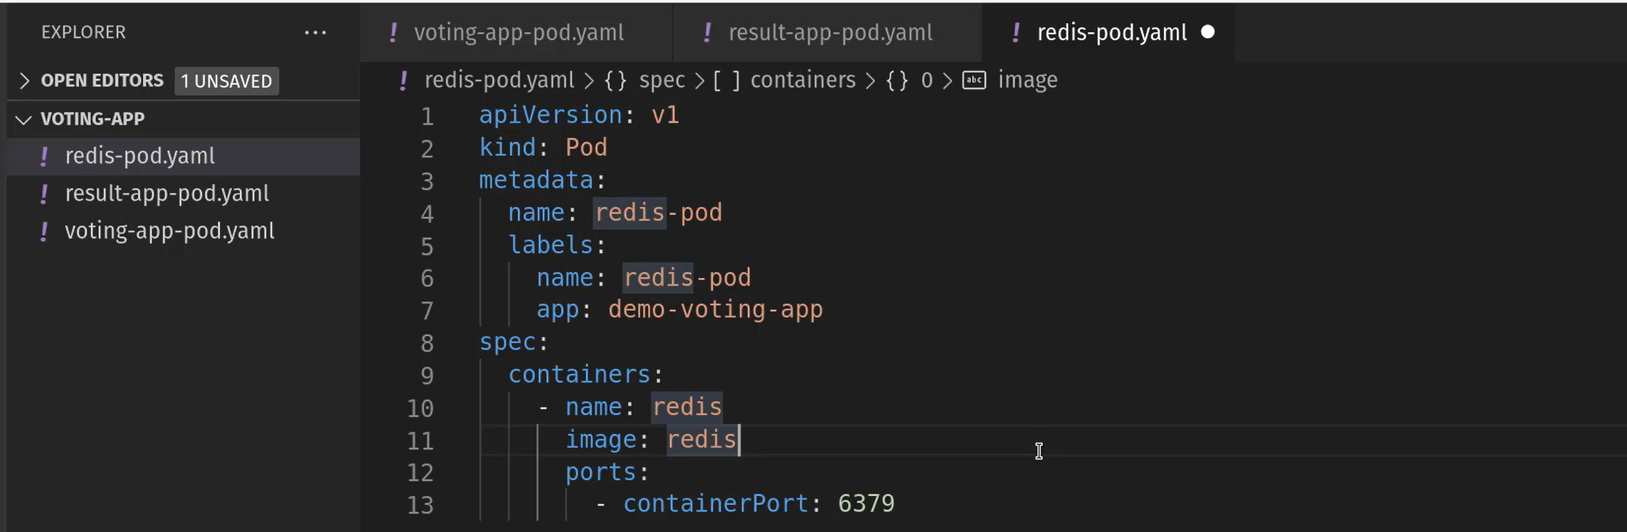 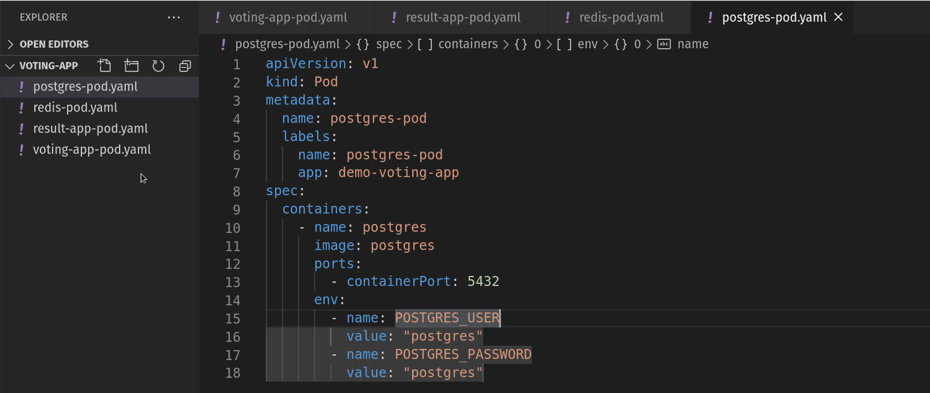You need to mention the credentials of postgres DB as they are already hardcoded in the source code. Use environment variables to declare these values. While creating cnatiner using pod definition file we have to declare them. If not, result and worker won’t be able to access DB.

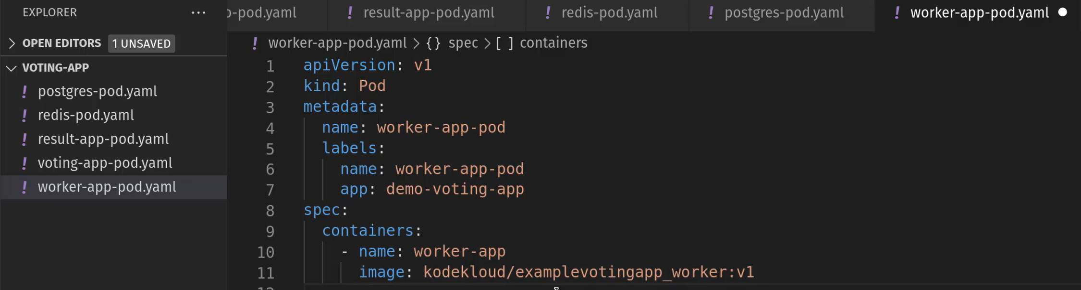Worker app don’t have any services listening. So, no port definition is required. We now had 5 pod-definition files for all our micro services.

Now, lets create Internal services yaml files. 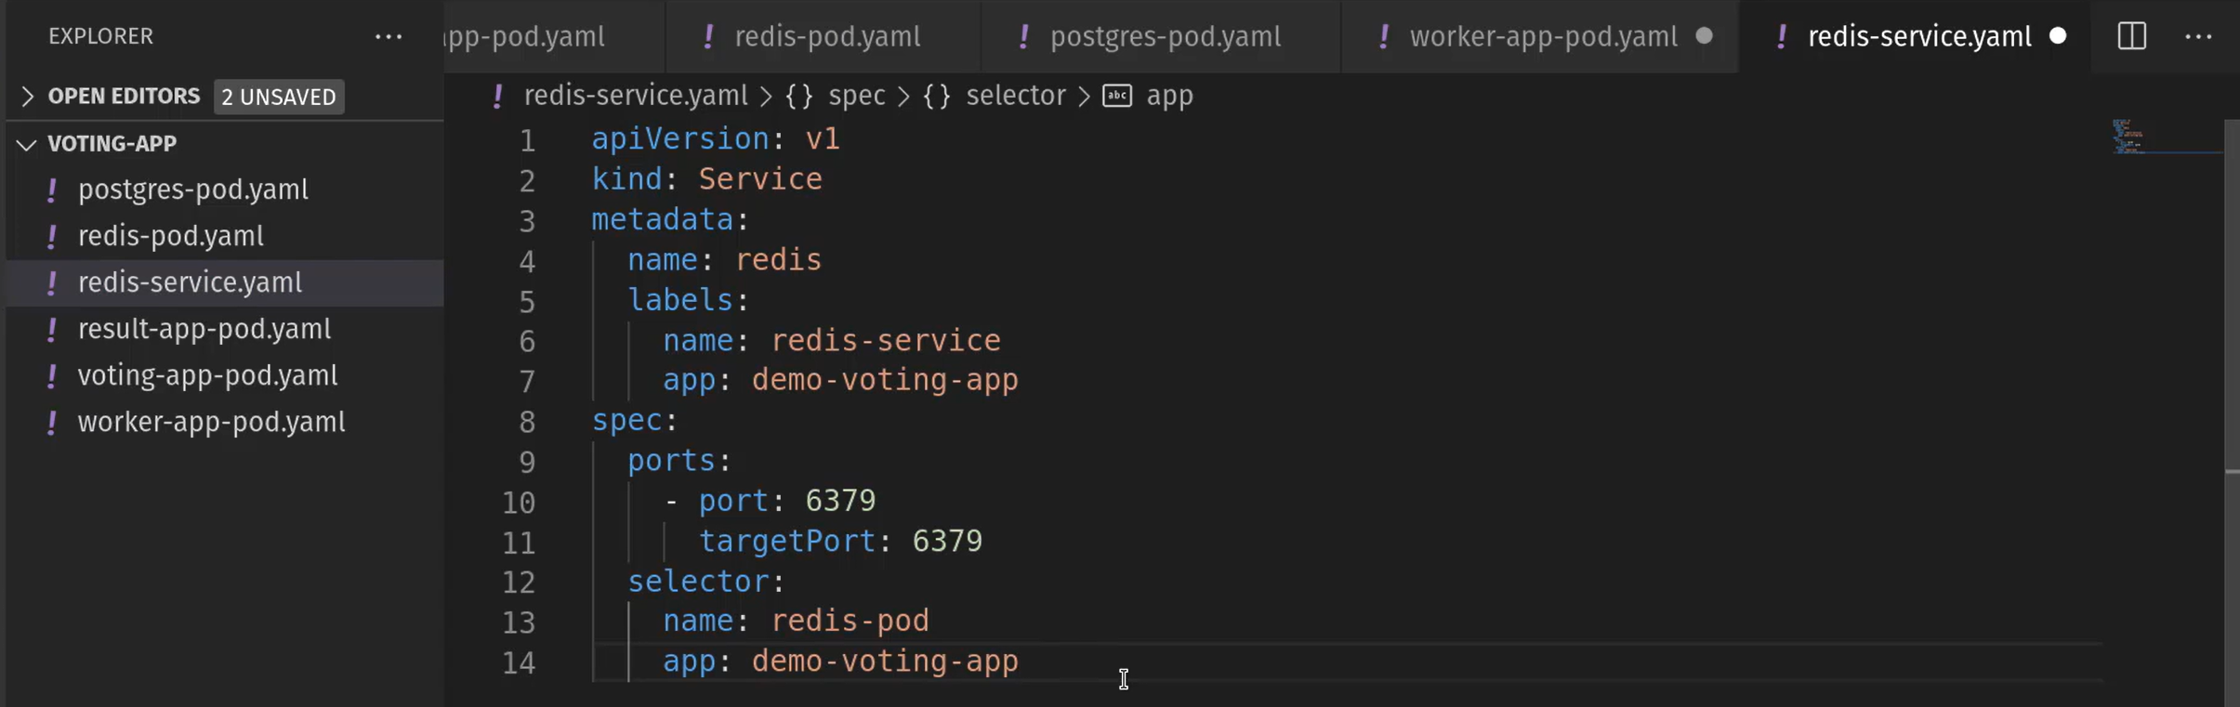Name of this service should be as per the name from source code. It is expected to be “redis”. copy the labels from the pod definition file and paste it in the selectors section. lAbles of theis service you can give anything. Since this in internal service we are not going to expose it outside on the network. So, you can’t see NodePort. This is ClusterIP service. If didn’t mention it will be considered by default. 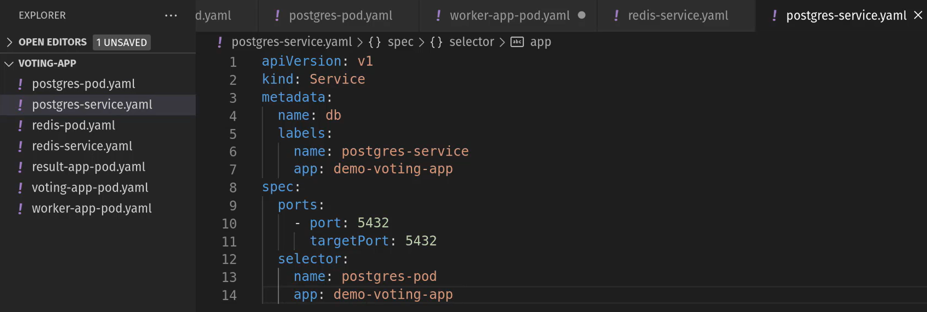Same, the name of the postgre service should be “db” as per the source code. The host will look for that db. Lables you can give any. Copy the labels given in postgre pod definition file and paste them in the selectors. We are done with creating two internal facing services.

Now, lets create the external facing services.

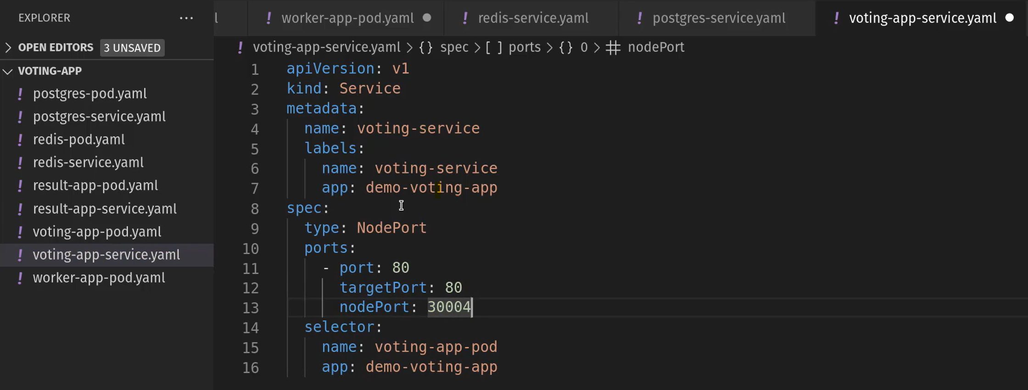Give any lables for this service and then change the port numbers. Copy lables from Voting pod definition file and paste them in the selector section. Since it is extrnal facing service we need to expose it. We need to specify service type as **NodePort.** 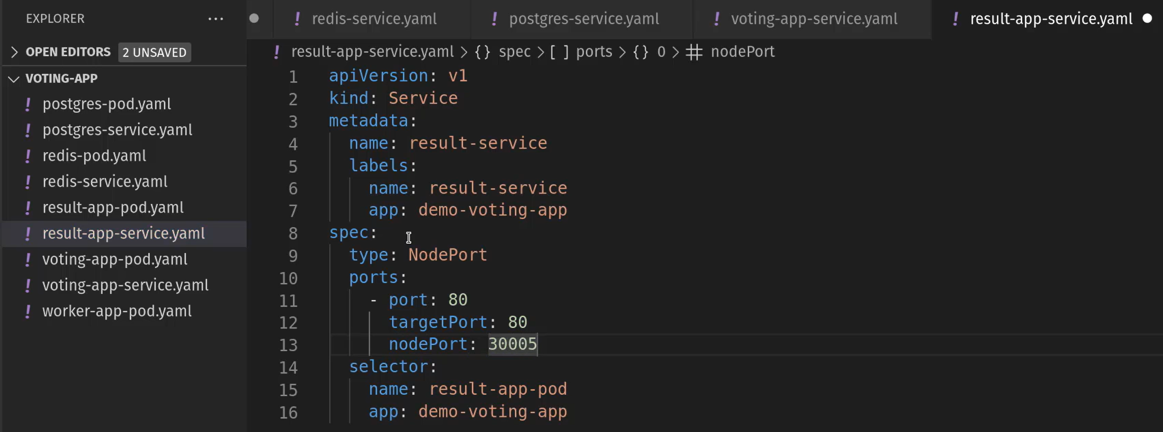Same, result app service is also an external service. So we will declare it as Nodeport and add labels of our choice, then add port numbers, then add lables form result pod definition file to selector section here in this file.

We have created all the files. Now, we have proceed with creation of these objects. Then we will try to access the web application from the web browser. 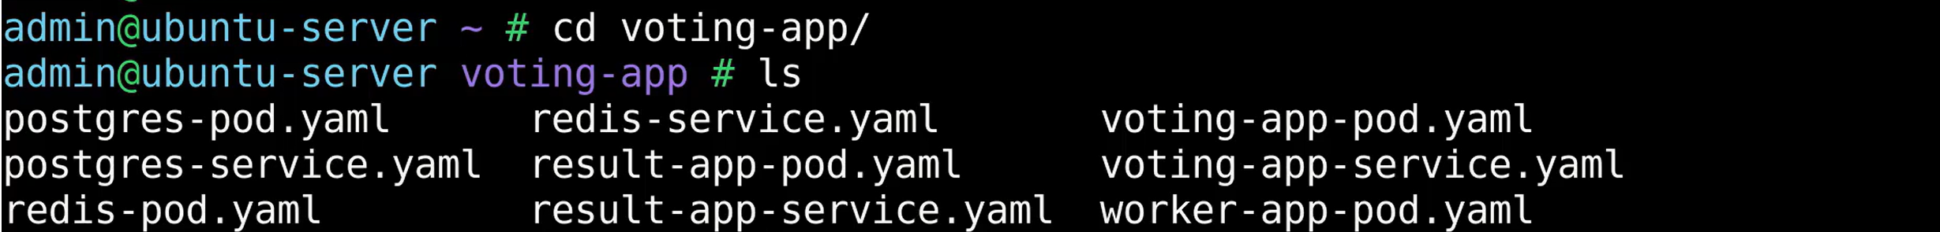 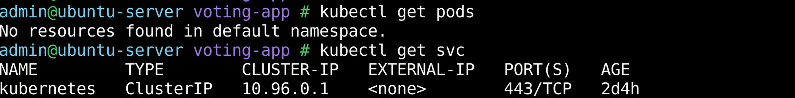There is nothing other than defaukt K8 service. That is created when we initiated K8 installation.

First create the pod for voting app and then the service of voting app:  Creating service for voting app: Let’s inspect the status of the pod and service at the same time. 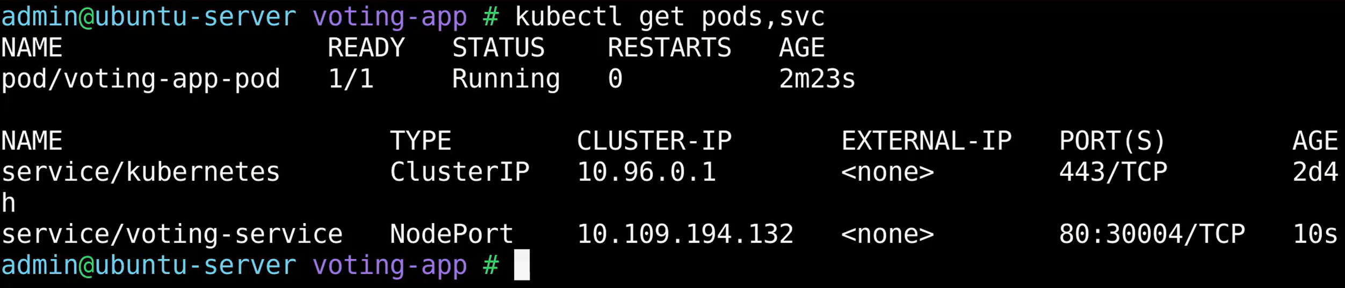We can see the service is created and it is of NodePort and can be accessible with Port 30004. It is up and running. Before going further, lets see how the application works with current status.

We need to know the URL to access. For that we need Port number and IP address of the minikube node. If we were not sure how to check the IP of that. Can give this below command directly to know the URL. Mention the name of the service with ‘--url’ option. You can copy this URL and try to access this in the local browser. 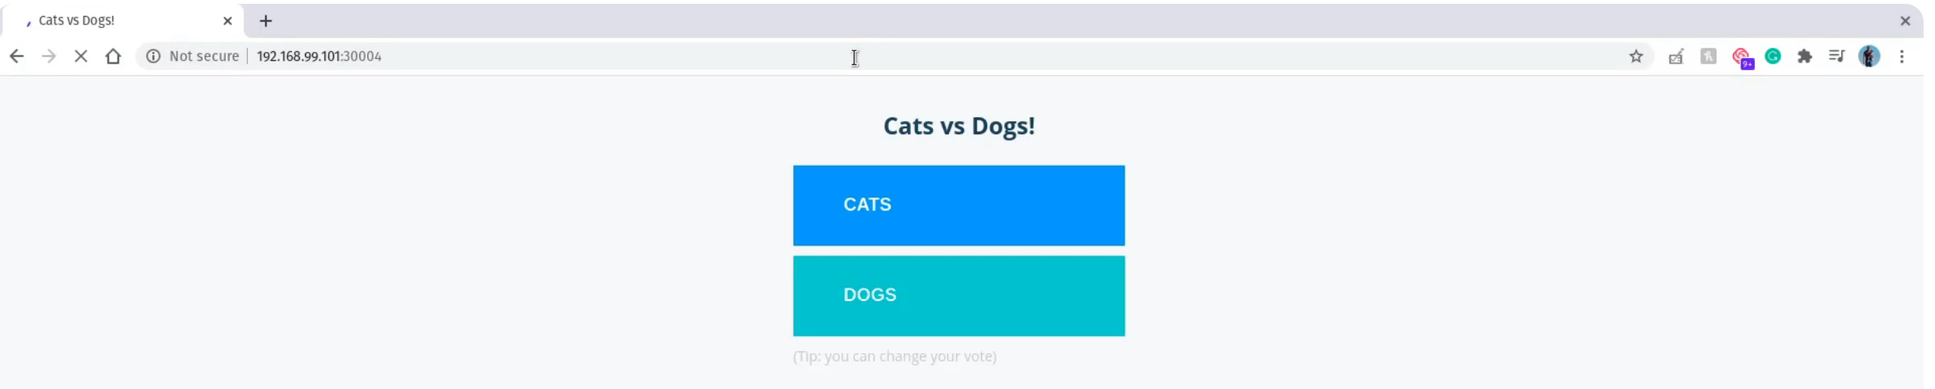let’s not try to caste the vote as we are not ready with db. Let’s go ahead and create the othe rpods and services.  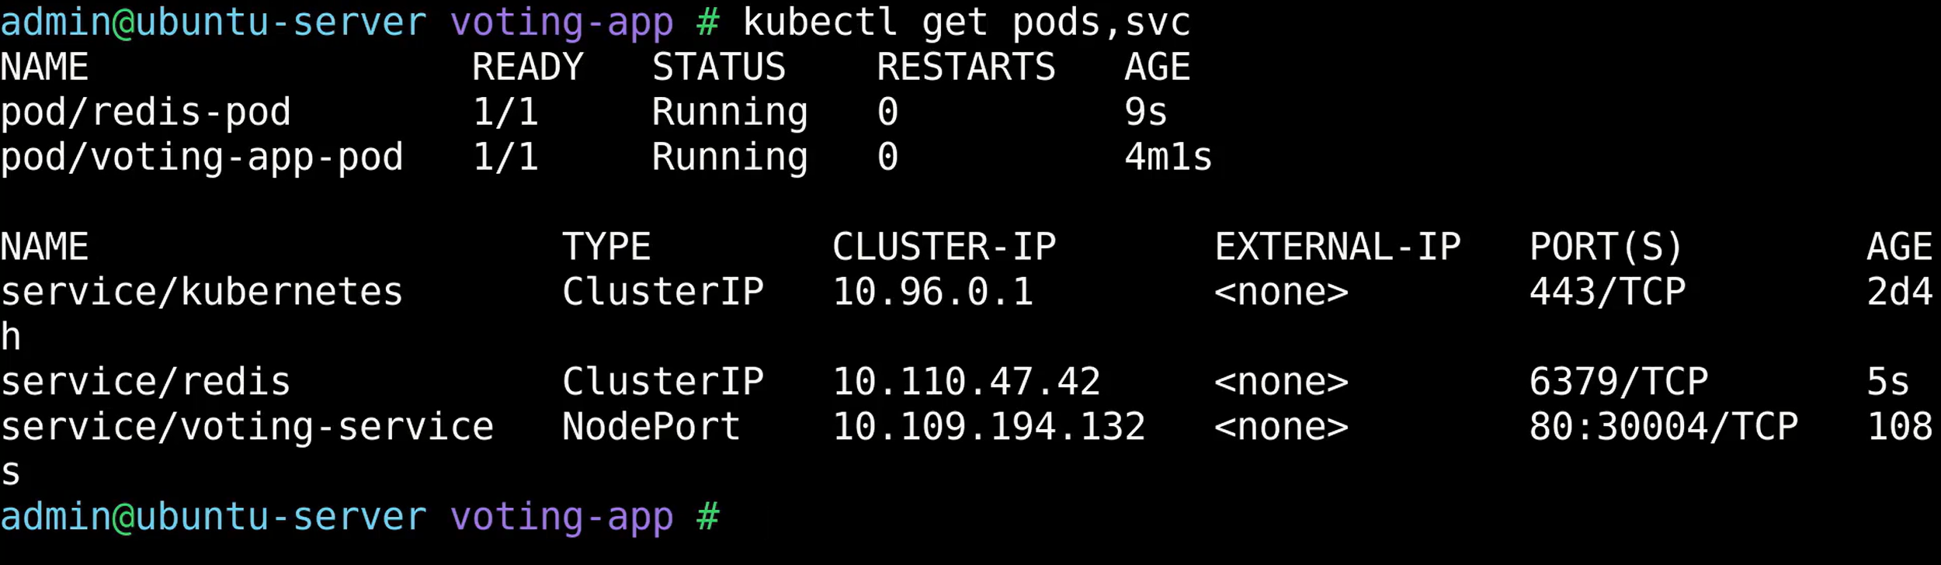You can see redis pod created and service with all the details. 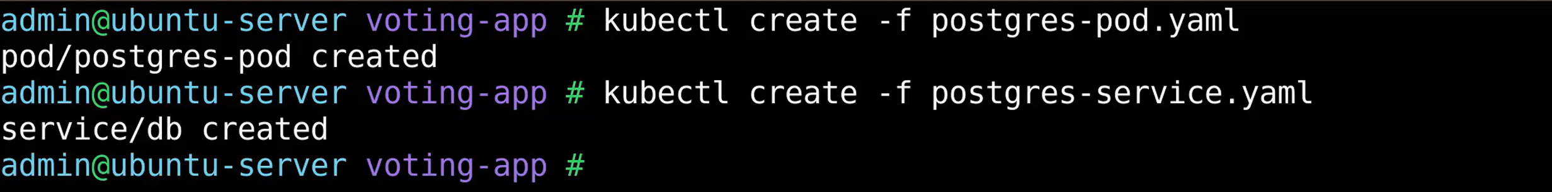 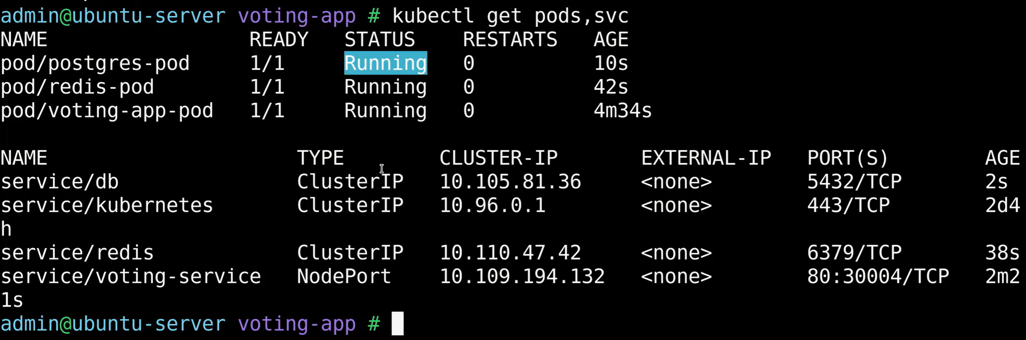Postgres service and pod are up and running. Let’s now create Worker pod. 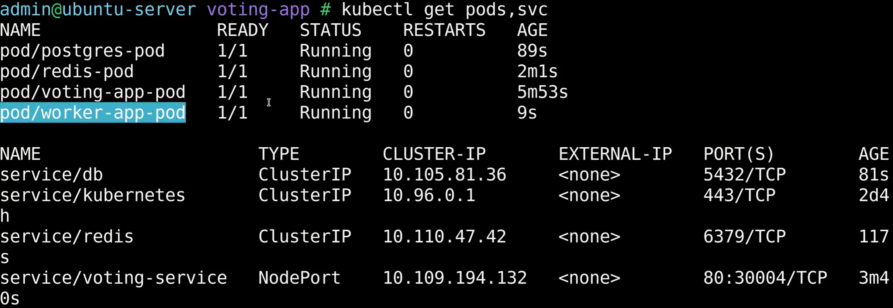We can see worker pod is also up and running. Let’s create the result app pod and result app service. Now you can see the status of all the five pods and 4 services along with default K8s services.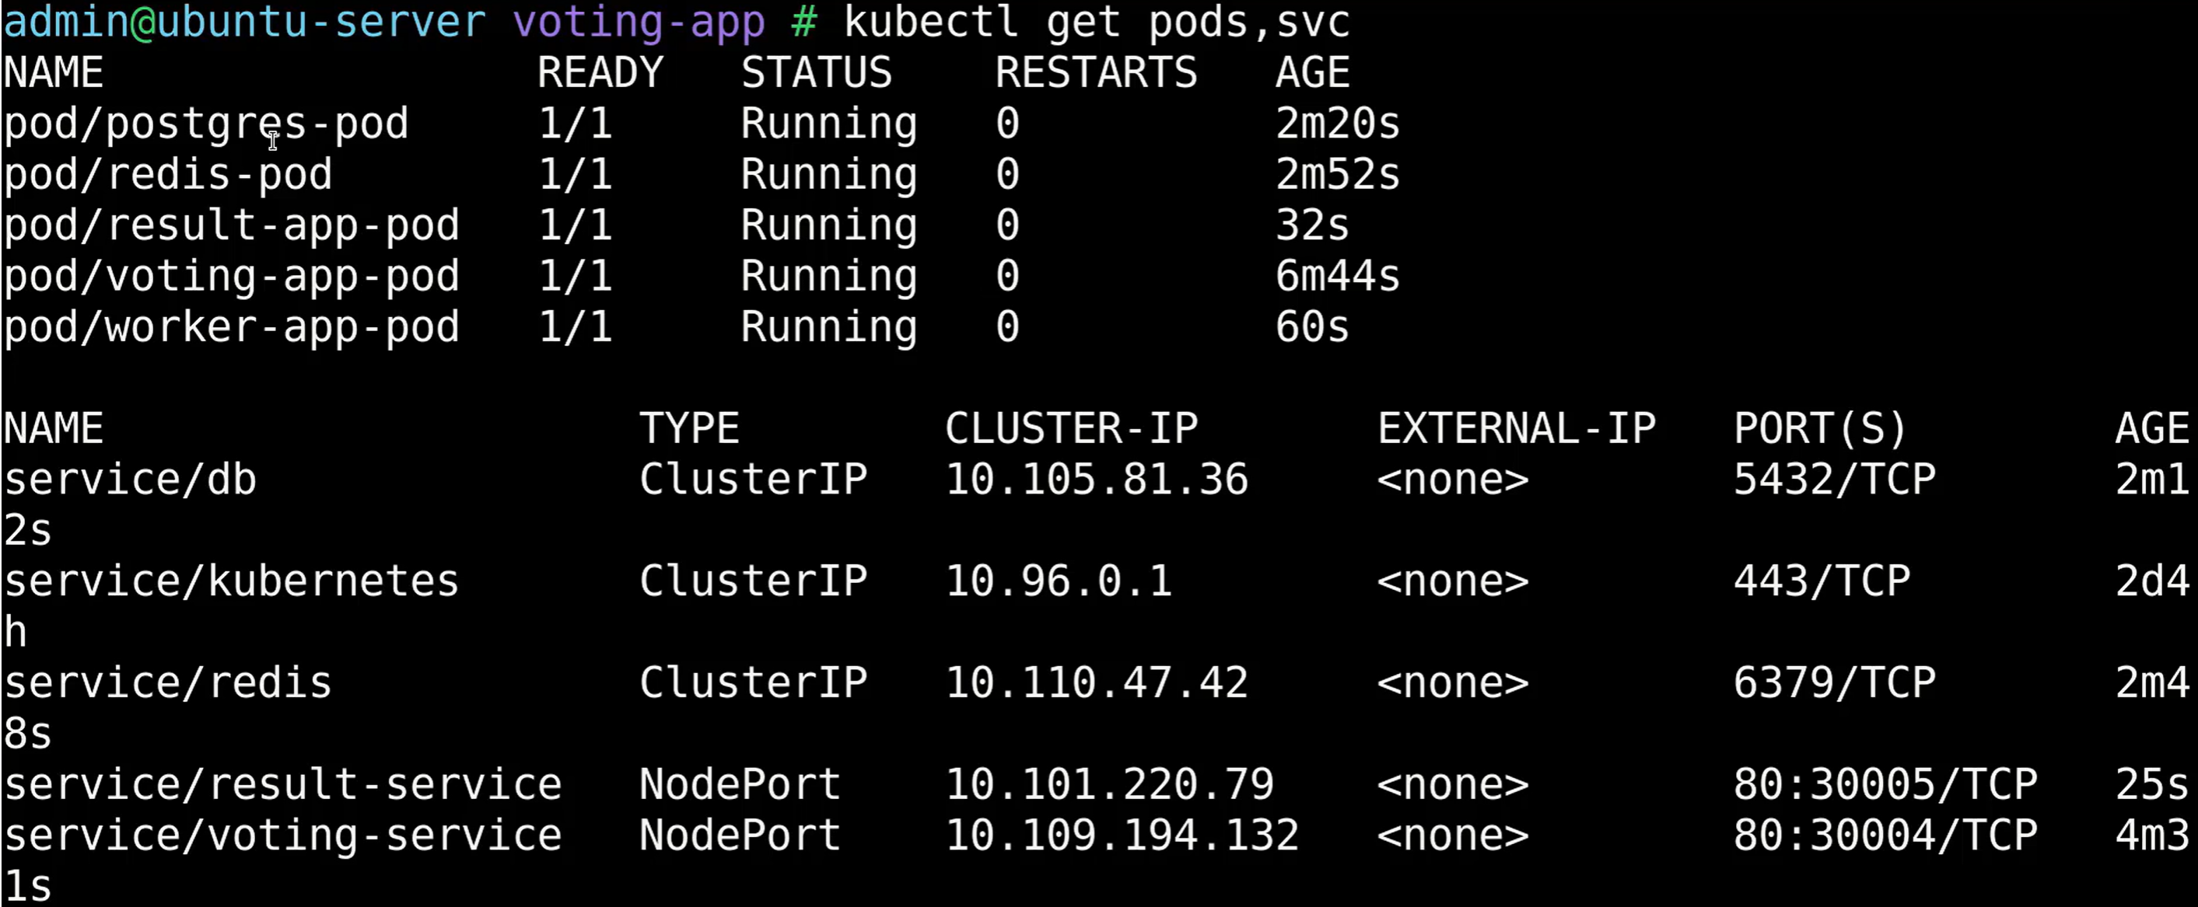Let’s also generate URL for the result app. We now have both the URL’s. Open both URL’s in tow different tabs. Refresh or open again the voting web app opened in web browser. Haven’t casted any vote yet.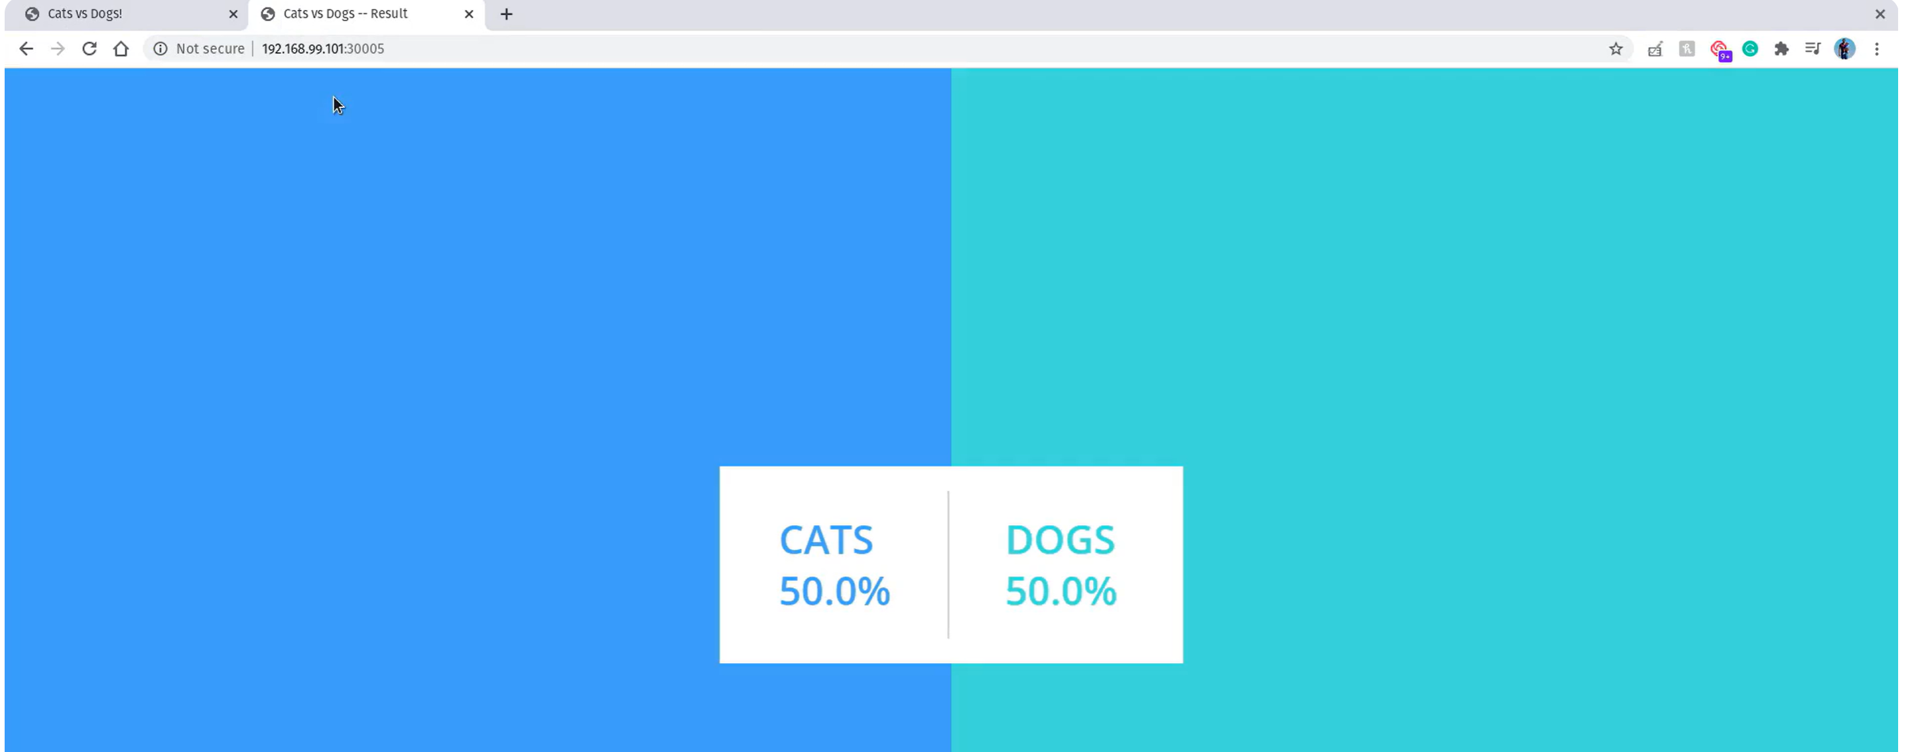

Now, try to caste a vote to the dogs. 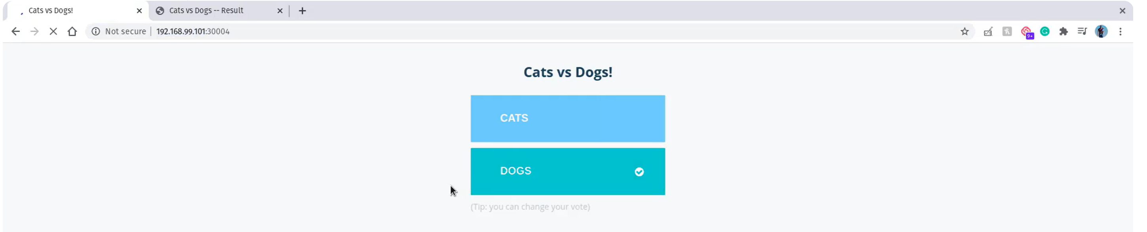Tick mark on the option indicates that vote had been recorded. It is saved in the redis db. And this vote is processed by the voting app pod. You can see the results page. 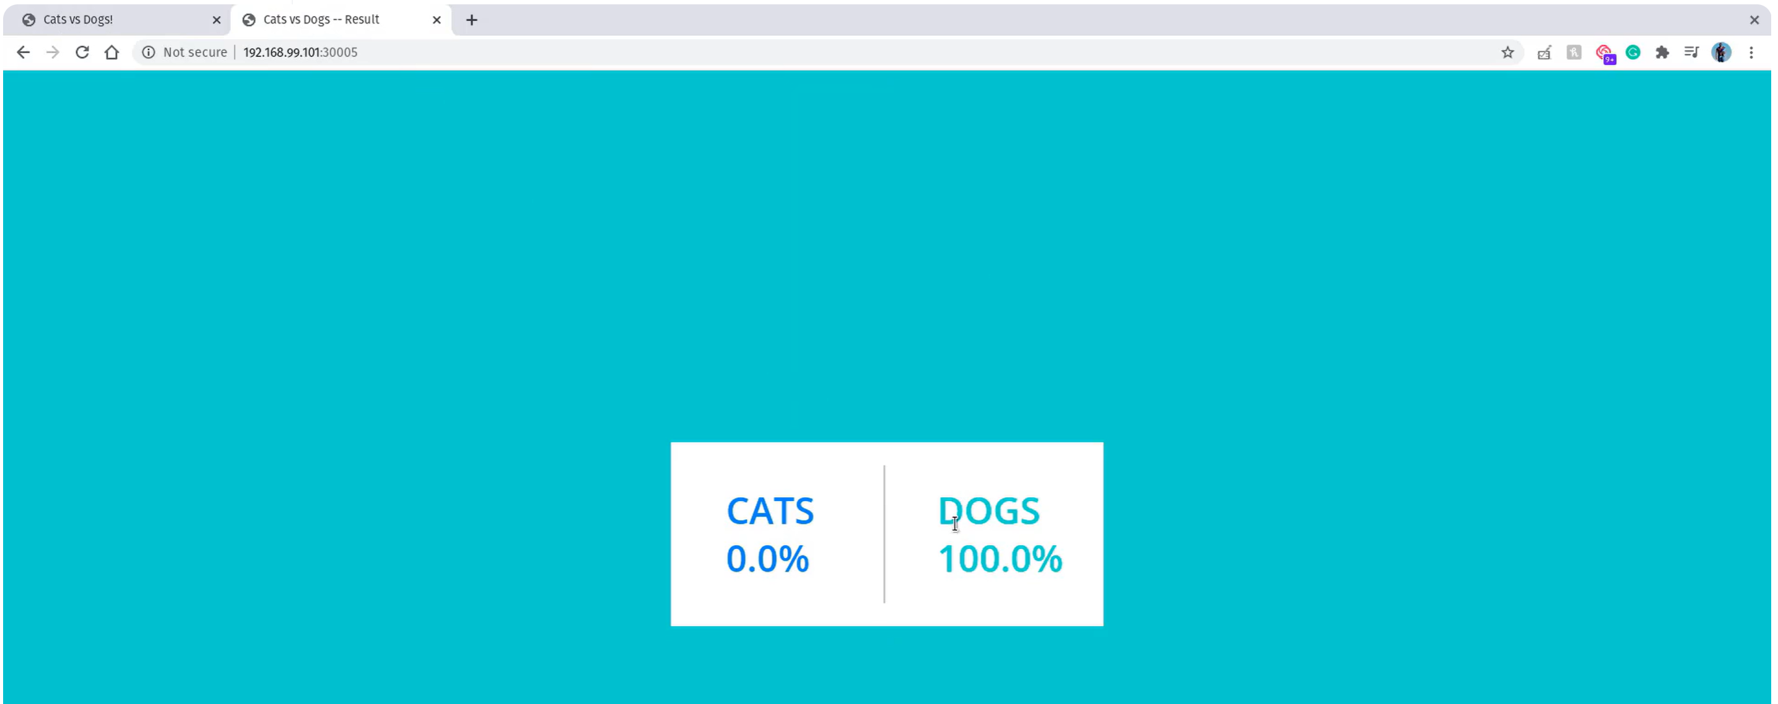You can go back and change the vote. 